**Install Ansible on CentOS 6.9**

**Step 1:** Set**EPEL** Repository

Ansible package is not available in the default yum repositories, so we will enable EPEL repository for CentOS 6.8 using the command below:

**# sudo rpm -ivh http://dl.fedoraproject.org/pub/epel/6/i386/epel-release-6-8.noarch.rpm**

This will download all the necessary packages which will be required to install Ansible.

**Step 2:** Install Ansible

**# sudo yum install ansible –y**

To check Ansible version

# ansible --version

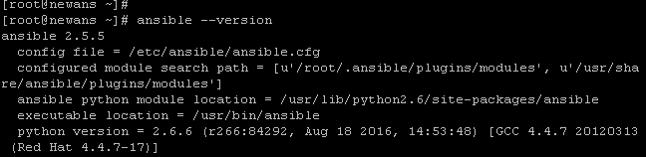

After installing Ansible you need to add servers which you want to manage through Ansible. For that I have created another CentOS VM which will act as my node machine.

The first task is to setup password-less SSH authentication with nodes on my Control machine.

Switch to your Node machine

**Step 1:** Generate SSH key on the Ansible Control Machine. In order to do that, use the command below:

**# ssh-keygen**

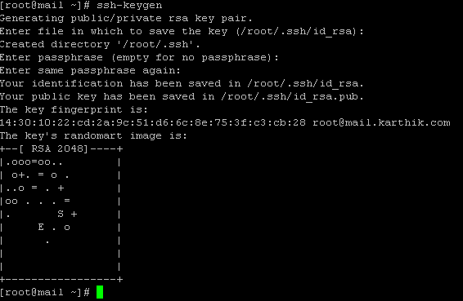

**Step 2:** Now, check the IP addresses of your nodes because you will need to specify it in the Ansible inventory later

**#** ifconfig

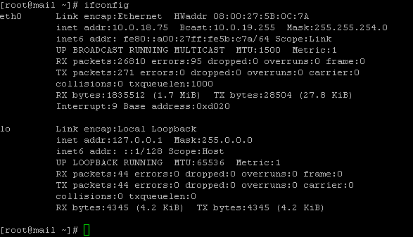

**Step 3:** After the key is generated, the next task is to copy public key of Ansible server to its nodes

Switch to your Ansible Server machine

**# ssh-copy-id -i root@<ip address of your node machine>**

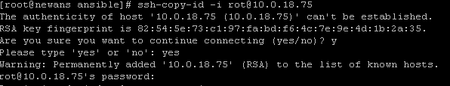

**Step 4:** Now, you can use any editor to write your inventory or specify the IP addresses of your nodes grouped under ‘test-servers’

**#**  **vim /etc/ansible/hosts**



**Step 5:** You might want to check if the IP address of your host has been added or not. To sample output of the host files using the following command:

**# cat /etc/ansible/hosts**

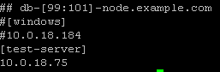

**Step 6:** Let us now perform a simple ping operation to test the connectivity using Ansible. To do that, just type the following command:

**# ansible -m ping ‘test-servers’**

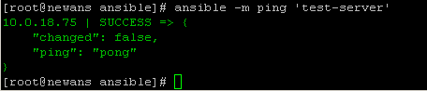

**Deploy Nginx Using Ansible**

Use the following command in your control machine:

**Step 1: # ansible test-servers -m yum -a “name=nginx state=installed”**

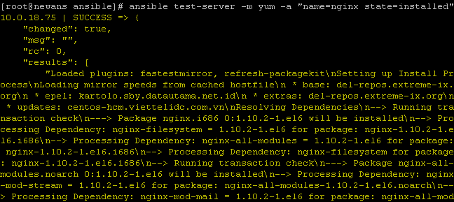

Now to check if it is installed in your node machine, type the following command in your node:

**# ps waux | grep nginx**

